In order to proceed created a database named employees using below command-

**CREATE DATABASE employee;**

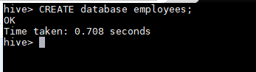

After that created table emp using below DDL-

**CREATE TABLE emp**

**(**

**Emp_id INT,**

**Emp_name STRING,**

**Sal INT,**

**Dept INT,**

**)**

**ROW FORMAT DELIMITED**

**FIELDS TERMINATED BY ‘,’;**

After defining table we loaded the table from input file placed in local using below command-

**LOAD DATA LOCAL INPATH ‘/home/acadgild/hive/employee_details.txt’**

**INTO TABLE employees.emp;**

Below is the screenshot

